Placer County Water Agency
Middle Fork American River Project
(FERC Project No. 2079)
DRAFT
Description - Operations Simulation Model

Placer County Water Agency
144 Ferguson Road
Auburn, CA 95604
January 2008

TABLE OF CONTENTS
Page
1.0 Introduction 1
2.0 Background 1
3.0 Model Structure and Operation 2
3.1 MFP Description 2
3.2 Operating Constraints 2
3.3 Operating Objectives 4
3.4 Priorities and Weighting 4
3.5 Fundamental Assumptions 4
3.6 Model Operation 5
4.0 Model Input 6
4.1 Hydrology 7
4.2 Consumptive Demands 7
4.3 Tunnel and Penstock Capacities 8
4.4 Water Year Types 8
4.5 Minimum Instream Flow Requirements 10
4.6 Reservoir Storage Requirements 12
4.7 Recreation Flows 13
4.8 Power Demand Index 14
5.0 Reservoir Operations 14
5.1 Forecasting Inflow 14
5.2 Precipitation Records 15
5.3 Dry Year Storage 15
5.4 Duncan Creek Diversion Dam 15
5.5 Long Canyon Diversion Dams 15
5.6 Middle Fork and Ralston Powerhouses 16
5.7 Combined Reservoir Storage 16
5.8 MFP Carryover Storage Target 16
5.9 Generation: Fill Cycle 17
5.10 Generation: Dispatch Cycle 18
5.11 Reservoir Spills 18
5.12 Reservoir Balancing 18
5.13 Oxbow Powerhouse 19
5.14 Maintenance Periods 19
5.15 Term 91 21
5.16 Water Forum Agreement 21
5.16.1 PCWA Water Forum Obligations 21
5.17 Refill Agreement 22
6.0 Model Output 22
6.1 Model Output 22
6.2 Summary of Simulation Results 22
6.2.1 Tabular Results 23
6.2.2 Standard Output 23
6.2.3 Graphical Results 24
6.2.4 Reservoir Storage 24
6.2.5 Flows in Diversion and Downstream Reaches 27
6.2.6 Generation 28
6.3 Diagnostics 30
6.3.1 Balance.out 30
6.3.2 OCL.out 30
6.3.3 LP.out 33

List of Tables
Table 1. Water Year Types (current storage requirements)
Table 2. Water Year Types (current minimum instream flow requirements)
Table 3. Water Year Types (proposed)
List of Figures
Figure 1. Operations Simulation Model – Arcs and Nodes Structure
Figure 2. Operations Simulation Model - Flow Chart
List Of Appendices
Appendix A. Demand Pattern Table
Appendix B. Tunnel and Powerhouse Capacities
Appendix C. Operations Control Language Input Guide
Appendix D. Load Curve Derivation
Appendix E. Target Descriptions
Appendix F. Model Standard Output List

Introduction
Placer County Water Agency (PCWA) and participating stakeholders anticipate analyzing the effects of proposed license conditions on operations of the Middle Fork American River Project (MFP) (FERC No. 2079) relicensing. Because changes in the actual operations of the MFP cannot be made to test alternative operating conditions, a computer-based simulation model was developed to evaluate effects of the alternative license conditions. The MFP - Operations Simulation Model (Model) was developed and is available for this purpose. The Model allows investigations of the relationships between water and power supply operations and environmental and recreational benefits under alternative scenarios designated by the model user.

Background
The MFP consists of two storage reservoirs (French Meadows and Hell Hole reservoirs), two regulating reservoirs (Middle Fork Interbay and Ralston Afterbay), three small diversions dams, and five powerhouses with interconnecting tunnels and penstocks. Diversions of water for MFP operations directly affect flows in Duncan Creek, the Middle Fork American River, the Rubicon River, and Long Canyon Creek. Operations of the MFP affect flows in the Middle Fork American River below Ralston Afterbay Dam and the Oxbow Powerhouse. (For a detailed description of project facilities see Placer County Water Agency, Middle Fork American River Project Draft Pre-Application Document, 2007).

The MFP is water-limited. Sufficient water only is available, on average, to operate water conveyance facilities (tunnels and penstocks) and powerhouses at full capacity part of the time each year. Annual MFP operations generally follow a pattern of refilling the storage reservoirs (French Meadows and Hell Hole) during winter and spring runoff periods, then releasing water through the summer and fall months to meet consumptive water and electrical demands. At all times, releases are made to meet minimum instream flow requirements.

The Model has been prepared to allow users to evaluate the following:

- The effect of hydrologic variability (water availability)
- Changes to minimum instream flow requirements
- Changes to minimum reservoir storage levels
- Changes in the annual carryover storage target
- Other specified flow requirements (pulse flows, recreation flows, etc.)
- Limits on the rate of change (ramping rates) in reservoir elevation and river stage over specified time periods
- Implementation of Project betterments

Model Structure and Operation
The Model is an application of the standard computer-based hydrologic model OASIS with OCL™ developed by Hydrologics, Inc. Implementation of the OASIS model for the MFP relicensing includes the following key features.

MFP Description
The MFP is described in the model by a network of arcs and nodes. A node is any location of interest; it may be a reservoir, a junction of two river reaches, or a diversion point. An arc connects two nodes and represents a flow of water, be it a river reach, tunnel, or penstock and powerhouse. A diagram of the arc-node structure used to describe the MFP and its related waters is shown in Figure 1 – MFP Operations Simulation Model Arc-Node Structure. The data used to develop the diagram is contained in the Arc table in the Model.

Operating Constraints
Within the context of running the Model, constraints are rules that the model should obey when operating the system. System constraints built into the model include the following:

Physical Capacities: Maximum reservoir storage capacity, maximum tunnel flow capacity, generating unit flow capacity, minimum operational reservoir elevations.

Regulatory and Contractual Requirements: Examples of regulatory and contractual requirements include: minimum instream flow requirements (flow rate and time period), minimum reservoir elevations (elevation and time period), maximum allowable diversions (volume and time period) for power and consumptive uses, contractual delivery requirements.

These requirements are slightly different than physical constraints. Physical constraints cannot be violated in a simulation, but regulatory and contractual requirements can. Alternatives will be developed and tested with the Model. Some of the alternatives tested with the Model may not be practicable, and may cause violations of minimum instream flow requirements or minimum storage requirements. Although these alternatives cause violations the
Figure 1. Operations Simulation Model – Arcs and Nodes Structure 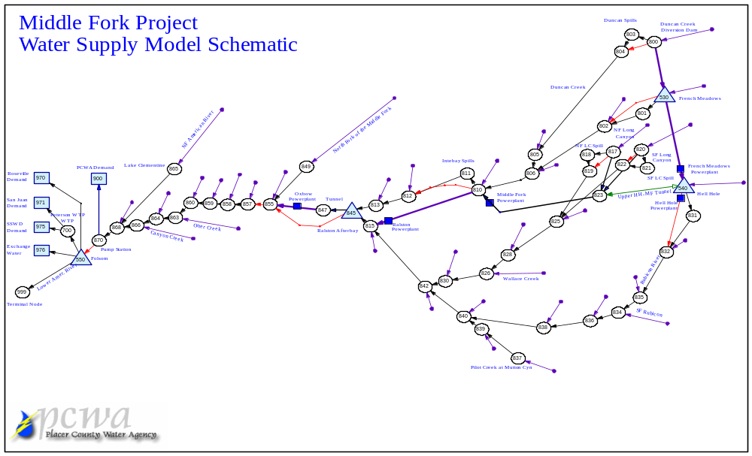
results can still be useful. Allowing violations is a necessary way to allow the model to complete the simulation.
  - Operating Objectives
When running a simulation, the model is set to maximize the achievement of specific objectives to the extent possible within the constraints specified. When water supply is limited, the model may not be able to achieve all objectives equally. The model prioritizes the objectives by the “weighting” assigned by the user. The objectives include:

  - Meeting consumptive water demands;
  - Minimum instream flow requirements;
  - Achieving maximum reservoir storage levels by the end of the filling cycle;
  - Avoiding reservoirs spills during filling;
  - Operating to hit end of year target carryover levels;
  - Concentrating power generation into periods of greatest power demand; and
  - Conducting maintenance during a specified period in the fall.

Priorities and Weighting
The model uses both priorities and weighting to determine relative importance of operating objectives. Priorities are distinct classes, and objectives that are priority 1 are more important than objectives in priority 2 regardless of weights. Weights are then used within priorities to determine importance. In this model almost all objectives are priority 1. Only reservoir balancing is placed in priority 2. The ordering of objectives is mostly done through the use of relative weighting. The objectives listed above are “in order” (i.e., top to bottom of priority) and represent the weighting structure. Consumptive water demands are all weighted higher than any other objectives. Minimum instream flow requirements are weighted below consumptive demands, but higher than any other objectives, and so on.
  - Fundamental Assumptions
Please note that certain fundamental assumptions, priorities, weightings and physical capacities are integral to the operation of the model. Changes to these fundamental assumptions, priorities, weightings and physical capacities may require additional changes to the model architecture, and/or re-benchmarking of model results, to ensure continued model integrity. Changes to the assumptions, priorities, weightings and physical capacity parameters listed in Appendix B require vetting with the model steering committee.

  - Model Operation
After operating constraints and operating objectives have been defined and hydrology has been selected, the model is run to simulate the assumptions. The model runs day-by-day in the following sequence of steps.

- The Oasis program reads the arc and node tables, the list of Operating Constraints (such as minimum instream flow requirements and reservoir storage requirements), the Operating Objectives (such as consumptive water and energy demands, all other static data e.g., initial reservoir storages, etc.), and the selected hydrology. The Oasis program then creates a numerical model of the MFP, which is a series of mathematical equations to be solved simultaneously.
- As it operates, the model reads the historical water inflows, accretions/depletions, and other time series data for each day. The model also has access to Blue Canyon precipitation records, DWR Bulletin 120 forecast inflows, and other forecasted inflows to Folsom Reservoir that are used as triggering criteria for the model to use specific Operating Constraints (e.g., minimum instream flow requirements for different water year types).
- The model processes the daily input data and numerical model through an optimization routine to best meet the operating objectives. The model uses the beginning storage for the day, reservoir storage requirements, minimum instream flow requirements, maximum generation flows, and consumptive demands as constraints.
- The mathematical equations in the model are solved to determine the system’s operation for one day at a time; the results are saved and written to a results file. Each day’s results are used as the beginning point for simulation of the next day’s operations.
- The program goes on to the next day. Through its optimization routine, the daily model run allocates daily power releases to meet consumptive and energy demands after meeting the Operations Constraints. The model continues cycling day-by-day through the user-specified time period specified (typically for the period of record (1975-2006), but also for shorter time periods such as a year).
- After completion of the model simulation, post-processor computer programs read the results file and summarize the simulation results by preparing tables and graphs showing information selected by the user. The types of tables and graphs that are expected to be prepared are described in Section 6.0 - Model Output.

Figure 2. Operations Simulation Model - Flow Chart
INPUT
MODEL
OUTPUT
Hydrology Data
MFP Description
ARC/NODES
Physical Capacities
Operation Constraints
Operational Rules
Instream Flow Requirements
Reserve Storage, Etc.
Model Daily Simulation
Operation Objectives
Water Demand
Power Demand Curves
Model Daily Simulation
Graphic Summary Tool

Model Input
To instruct the model to prepare a simulation, the user must modify selected inputs within a user input data file. The inputs are contained in thee forms: HEC-DSS files, static database tables, and Operations Control Language (OCL). The hydrology and related time series input can be found in the HEC-DSS files. Information about the physical description of the facilities are generally found in static database tables accessible through the Graphical User Interface. The OCL files can be used for any conditional operating rules or requirements. The OCL files may contain values or logic that the user may wish to change. Appendix C contains a table that lists the OCL files used with the daily time step model and a general description of the contents of each file. Inputs that can be specified by the user include the following:

Hydrology
A time series database of unimpaired hydrology is loaded into the model. The data is based on the available hydrologic record for the MFP, which is from water years 1975 through 2006, and is described fully in (2006 Hydrology Study Plan Report, 2007, PCWA). The user selects the time period to be simulated with the Model by selecting and designating specific years from the hydrologic record. A single simulation can include: 1) all years of record; 2) any group of sequential years; or 3) any specific year. The time period is selected in the Daily Run tab in the Model as shown. The default time period run is water years 1975-2006.

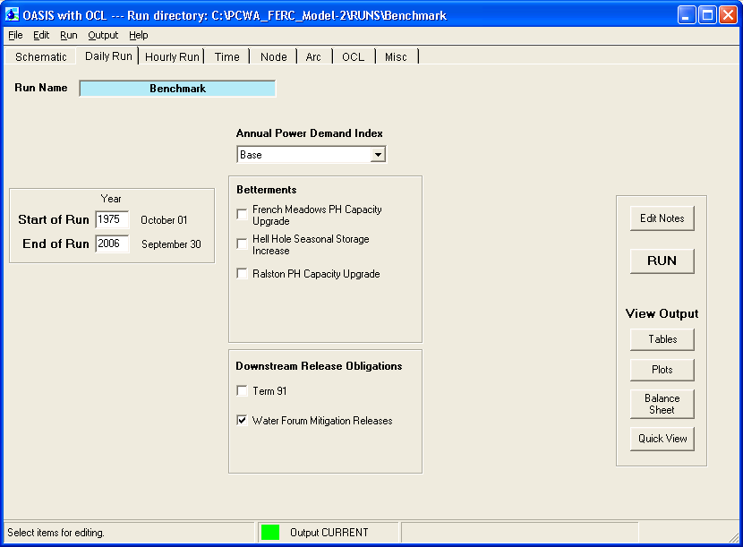

Consumptive Demands
All consumptive demands are contained in the _daily_demands.ocl file. These demands are set by multiplying a monthly pattern by an annual demand. The monthly patterns can be found in the Pattern table, and annual demands are entered into the constants table in acre-feet. Monthly patterns are described as each month’s fraction of the annual demand, and daily demands are the monthly demand distributed equally throughout the month. The patterns that are contained in the model are found in Appendix A – Demand Pattern Tables. Below are the first two commands in the ocl file _daily_demands.ocl, which set PCWA and Roseville demands. The annual volumes shown are for a current demand of 18.5 TAF, of which PCWA (American River Pump Station) demand makes up 8.5 TAF.

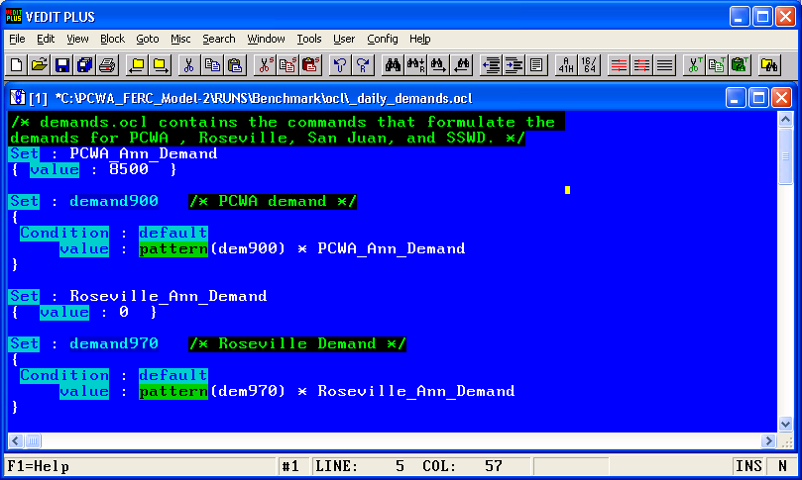

Tunnel and Penstock Capacities
Flow capacities are contained in the maximum flow table, which is accessed through Arc tab, or are set as the OASIS variable Max_flow in ocl commands, and are outlined in Appendix B – Tunnel and Powerhouse Capacities.

Water Year Types
The Model contains three water year type structures available for implementing specific minimum instream flow requirements and reservoir storage requirements. All three water year structures are based on the Folsom Reservoir Unimpaired Inflow.
Reservoir storage requirements in the current license are based on the three year-type structure shown in the table below.

Table 1. Water Year Types (current storage requirements)
Water Year  Type | Unimpaired Flow into  Folsom Reservoir
Wet | above 2,000,000 AF
Normal | 1,200,000 – 2,000,000 AF
Dry | 0 – 1,200,000 AF

Minimum instream flow requirements in the current license are based on the two year-type structure shown in the table below.

Table 2. Water Year Types (current minimum instream flow requirements)
Water Year  Type | Unimpaired Flow into  Folsom Reservoir
Wet | above 1,000,000 AF
Dry | Below 1,000,000 AF

The third water year type structure is the proposed water year types for the relicensing. The hydrologic record of the MFP (water years 1975 through 2006) has been sorted into water year types (wet, above normal, below normal, dry, and critical) based on the wetness or dryness of a given year. The wetness index is based on the unimpaired inflow into Folsom Reservoir downstream of the MFP. The water year types and corresponding Folsom Unimpaired Inflows that have occurred over the past 100 years (1901 – 2001) are shown on Table 3 below.

Table 3. Water Year Types (proposed)
Water Year  Type | Unimpaired Flow into Folsom Reservoir  (1901-2001) (Number of Years)
Wet | above 3,500,000 AF (30)
Above Normal | 2,600,000 – 3,500,000 AF (21)
Below Normal | 1,700,000 – 2,599,000 AF (17)
Dry | 900,000 – 1,699,000 AF (26)
Critical | 600,000 - 899,000 AF (7)

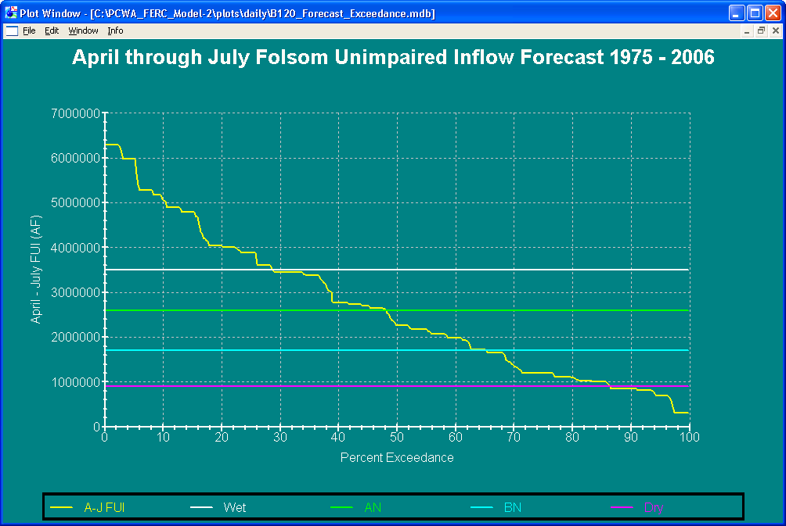

Minimum Instream Flow Requirements
The MFP is currently required to maintain minimum instream flows at eight locations as a condition of their water rights. Seven of these locations also have their minimum instream flow requirement as a condition of the FERC license. The required flows vary in relation to the water year types in Table 2 above and, at some locations, by the time of year. As an input into a simulation the user has the ability to specify variable minimum instream flow criteria at each of these 7 locations. The user can specify the time period over which the requirement applies, the flow rate, and a water year type to implement the criteria.

Current minimum instream flow requirements are as follows.

Duncan Creek
Wet : 8 cfs or natural inflow
Dry : 4 cfs or natural inflow
North Fork Long Canyon Creek 2 cfs or natural inflow
South Fork Long Canyon Creek
Wet : 5 cfs or natural inflow
Dry : 2.5 cfs or natural inflow
Below Interbay Reservoir
Wet : 23 cfs or natural inflow
Dry : 12 cfs or natural inflow
Middle Fork American River Below Oxbow 75 cfs
Middle Fork American River at Auburn 75 cfs
Rubicon River below Hell Hole Dam
Wet :
5/15 – 12/14 20 cfs
12/15 – 5/14 10 cfs
Dry :
6/1 – 10/14 10 cfs
10/15 – 5/31 6 cfs
Middle Fork American River below French Meadows Dam
Wet : 8 cfs or natural inflow
Dry : 4 cfs or natural inflow

Minimum instream flow requirements are set in the file _daily_min_flows.ocl and flow regimes based on time of year are entered into pattern tables. The screen capture below shows the default minimum instream flow requirement below French Meadows Dam.

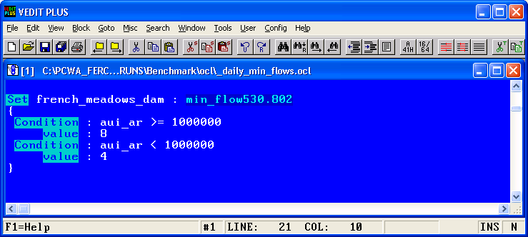

The screen capture below shows the monthly pattern for minimum instream flow requirements in Rubicon River below Hell Hole Dam. Hell Hole minimum instream flow requirements vary by water year type and also have a seasonal pattern. These seasonal flow requirements are entered into pattern tables; Hell Hole has two pattern tables for dry year and normal year flow patterns.

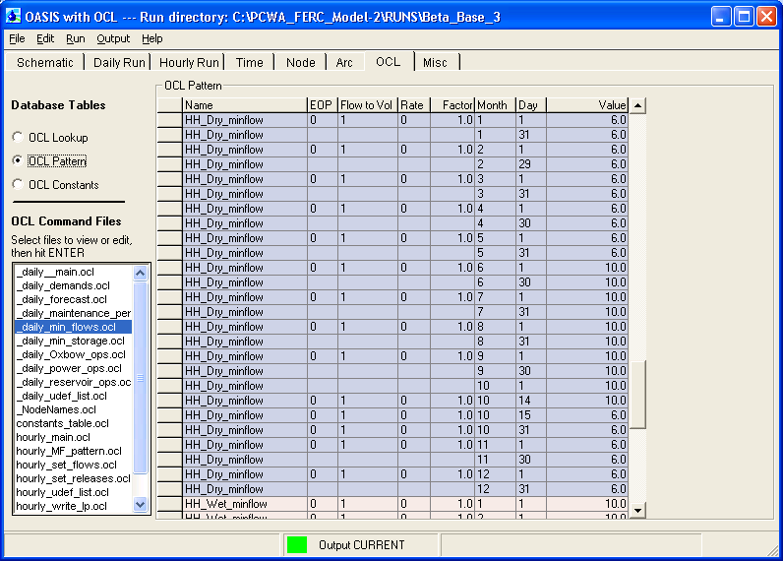

Minimum instream flow requirements are a goal in the Model and are allowed to be violated without stopping the model. A post-processing table is available for checking violations of minimum instream flow requirements.

Reservoir Storage Requirements
Reservoir storage requirements currently exist for French Meadows and Hell Hole reservoirs. Similar to the minimum instream flow requirements, the user may input criteria for specified time periods triggered by water year types. The requirements in the current license are outlined below.

French Meadows
Minimum Storage (AF)
 | Oct - May | June - Sep
Folsom Forecast < 1,200,000 | 8,700 | 28,000
1,200,00 < Folsom Forecast < 2,000,000 | 25,000 | 60,000
Folsom Forecast > 2,000,000 | 50,000 | 60,000

Hell Hole
Minimum Storage (AF)
 | Oct - May | June - Sep
Folsom Forecast < 1,200,000 | 5,500 | 26,000
1,200,00 < Folsom Forecast < 2,000,000 | 25,000 | 70,000
Folsom Forecast > 2,000,000 | 50,000 | 70,000

These requirements are set in the file _daily_min_storage.ocl as shown for French Meadows below.

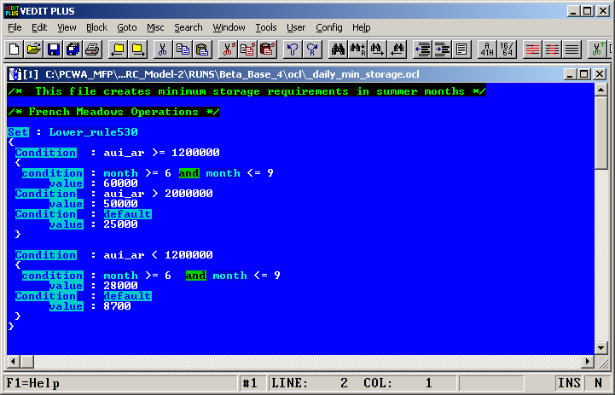

Recreation Flows
Recreation flows are composed of flow rate and flow duration (both for weekdays and weekends) and are set in the constants table, as shown below. These recreation flows take effect June through September and a volume is calculated as the day’s release to Middle Fork American River below Oxbow Powerhouse. Recreation flows are run through the Oxbow Powerhouse. Although the model is set up to include recreation flows, the default run contains no recreation flows.
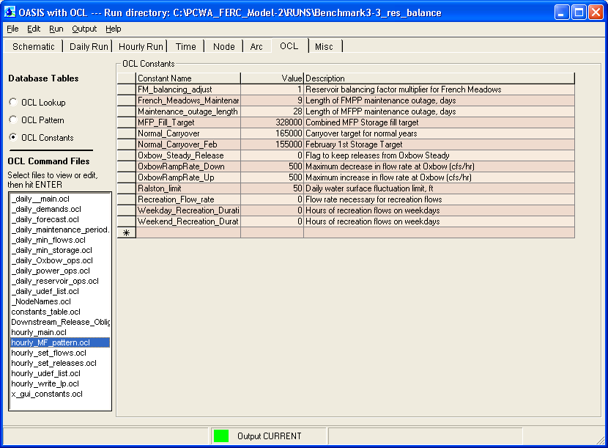

Power Demand Index
The model contains a daily statewide power demand index to shape generation releases to days of higher overall energy demand. A detailed discussion of the power demand curve and its derivation is available in Appendix D.

Reservoir Operations

Forecasting Inflow
The model utilizes three forecasts: American River annual unimpaired inflow; March - November unimpaired inflow to Folsom; and Bulletin 120 forecasts of April – July unimpaired runoff of the Middle Fork American River at Auburn.

- American River unimpaired inflow is represented by the variable aui_ar, and is defined as unimpaired runoff from October through March plus the forecasted April through September runoff. This forecast is updated in the model June 1st. This forecast is used to determine the reservoir storage and minimum instream flow requirements for the Project under the current FERC License.
- Folsom unimpaired inflow is represented by the variable fui_m-n and is defined as the forecasted unimpaired Folsom inflow from March through November. This forecast is updated March 1st and is used to determine the release targets as suggested in the Water Forum Agreement.
- Bulletin 120 forecast is used for forecasting monthly reservoir inflows. Bulletin 120 forecast of April – July runoff at Middle Fork American at Auburn is used to develop a forecasted inflow as a percent of average. This percentage is represented in the variable B120_forecast and is updated at the beginning of February, March, April, and May. The May forecast then holds until the next February.

The Bulletin 120 forecast percentages are then applied to Middle Fork Project monthly average inflows to get a forecasted MFP inflow for the current month. This is represented by the variable forecast_inflow and is updated at the beginning of every month. The Bulletin 120 forecasts are an estimate of April through July runoff; therefore, in May, the total April inflow is subtracted from the forecasted April through July inflow.

Precipitation Records
The model utilizes precipitation records from the Blue Canyon gage. These records are used as a weather forecast. The model looks ahead 7 days and totals the rainfall to check for large storms. When this 7-day total is larger than 4.5 inches during the winter, generation is increased. During the spring, generation is increased when the 7-day total is larger than 6.5 inches and total MFP storage is above 200 TAF. Precipitation records are used to simulate real-world operating conditions in which a project operator would use real-time weather to slightly modify project operations.

Dry Year Storage
The February 20, 1963 Bureau contract Article 1, paragraph (b), subparagraph (i) states that during a dry year the United States will require PCWA to release water from its Middle Fork Project such that the total quantity stored by the project shall be no more at the end of the year than it was at the beginning. Although the normal operation of the project generally does results in this type of operation, the Model ensures that the condition is always met.

Duncan Creek Diversion Dam
Duncan Creek Diversion is a passive system with limited operational control. The dam has a low flow outlet that releases 8 cfs when diverting or natural inflow, whichever is less. Because the manual gate typically is left open throughout the winter and spring, all flow above 8 cfs is diverted to French Meadows Reservoir, up to the capacity of the tunnel (400 cfs) Flows above 408 cfs are spilled over the diversion structure.

Long Canyon Diversion Dams
Diversions from Long Canyon include diversion from South Fork Long Canyon and North Fork Long Canyon. When diverting, the Long Canyon diversions have low-flow outlets that allow flows to pass the diversions to meet flow requirements. Flows above the minimum instream flow are diverted to the Hell Hole-Middle Fork Tunnel, up to the capacity of the tunnels (100 cfs for North Fork Long Canyon diversion and 200 cfs for South Fork Long Canyon diversion). The Long Canyon diversions are passive systems and the amount of diversion cannot be altered directly. Diversions from the South Fork and North Fork of Long Canyon Creek can flow into Hell Hole Reservoir during times of low storage in Hell Hole Reservoir. This reverse flow is represented in the Model as negative flow through the Hell Hole-Middle Fork Tunnel, and can occur when the Middle Fork Powerhouse is shut off or operating at a flow lower than is being diverted.

Middle Fork and Ralston Powerhouses
The Middle Fork and Ralston powerhouses are operated together. That is, Ralston Powerhouse generates whenever Middle Fork Powerhouse is generating and with approximately the same flow. This is because Middle Fork Powerhouse empties into Interbay, the Ralston powerhouse intakes from Interbay, and both powerhouses have similar capacities. Because of this, generation is calculated for Middle Fork powerhouse, and Ralston powerhouse generation is approximately equal to Middle Fork powerhouse.

Combined Reservoir Storage
The Middle Fork Project generally operates Hell Hole and French Meadows reservoirs as a single reservoir from a generation standpoint. Water for generation at Middle Fork powerhouse comes from Hell Hole reservoir and the Long Canyon diversions. In turn, the French Meadows powerhouse transfers water from French Meadows reservoir to Hell Hole reservoir, where it can then be used for generation at Middle Fork powerhouse. For this reason, generation at Middle Fork powerhouse is based on combined reservoir storage at both Hell Hole and French Meadows reservoirs and discussion of generation will be based on combined reservoir storage.

MFP Carryover Storage Target
The MFP Carryover Storage Target designates the combined total amount of water in storage in French Meadows and Hell Hole reservoirs on the carryover date. The MFP utilizes two carryover storage target dates, December 1st and February 1st. These values are set in the ‘constants’ table, in the variables ‘Normal_Carryover_Dec’ and ‘Normal_Carryover_Feb’ as shown in the screen capture below. The values are set at 165,000 AF and 155,000 AF, respectively. The user may elect to revise this value for an individual simulation run. During the dispatch cycle, the model looks to the December 1 carryover target during the months of July through November, and looks to the February 1 carryover target in December and January.
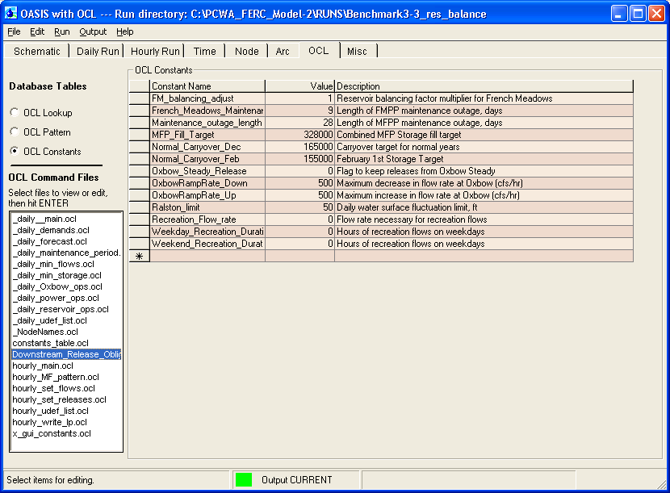

Generation: Fill Cycle
From February through the end of the fill cycle (which varies by water year type), a monthly generation volume is calculated on the first day of every month. Historic operations indicate that the reservoirs are filled earlier in dry years than in wet years. The model will try to fill the reservoirs to the annual maximum on June 15th for a dry year, July 1st for a medium year, and July 15th for a wet year. The generation volume is calculated as the end of the previous month’s storage plus the forecasted inflow, minus the fill target and flow requirements. During the fill cycle, meeting the required minimum instream flow requirements and filling the reservoirs are more important than generating power. If the forecasted inflow is not enough to meet the flow requirements and fill the reservoir, generation is minimized to fill the reservoirs as much as possible. If the reservoir(s) fill past a certain target and it appears that spill is possible, the generators are run harder to move more water through the system. During the fill cycle if the project is under control (i.e., not spilling), generation occurs when the power demand is highest. During the fill cycle, the power demand curve is accumulated from the current month through the end of the fill cycle. A daily power demand ratio is then determined by dividing the power demand for the day by the accumulated power demand for the dispatch cycle. This fraction is then multiplied by the monthly generation volume, resulting in the day’s generation target.

Generation: Dispatch Cycle
During the dispatch cycle (end of the fill cycle through January) a monthly generation volume is calculated on the first day of every month. This generation volume is calculated as the storage at the end of the previous month plus the forecasted inflow from the current month through the end of the dispatch cycle, minus the carryover target and flow requirements. During the dispatch cycle, the power demand curve is accumulated from the current month through the end of November, and accumulated through the end of January after December 1st. A power demand ratio is then determined as the power demand for the day divided by the accumulated power demand. This fraction is multiplied by the monthly generation volume, resulting in the day’s generation target.

Reservoir Spills
French Meadows has a radial spillway gate that must be up from November 1st through the end of March. When the gate is up, French Meadows has a storage capacity of 111,602 AF. When the gate is down, French Meadows storage capacity increases to 134,993 AF. Flow is not allowed in the spillways when the reservoirs are below full capacity. In the model, the reservoirs, when full, will pass the inflow through the spillway arc rather than through the outlet works. Below each reservoir there are two arcs allowing flow to the main channel down below, a minimum instream flow requirement arc and a spills arc. The minimum instream flow requirement arc has a high A weight and a negative B weight to discourage flows above the minimum instream flow requirement, while the spills arc has no weighting. For a thorough discussion of arc weights, see the OASIS user’s manual.

In order to reduce spills, a spill control switch is utilized as a flag to determine when reservoirs approach capacity. The spill control switch is turned on when total MFP storage goes above a year type-based threshold, and turned off when total MFP storage reaches 5,000 AF below that threshold. This is done to avoid negative feedback with the powerhouse releases. During spill control operations, Long Canyon contributions to Middle Fork Powerhouse are shut off and French Meadows Powerhouse flows at full capacity.

Reservoir Balancing
Reservoir Balancing is achieved through the use of French Meadows powerhouse. In general, French Meadows and Hell Hole reservoirs are operated together to meet consumptive and generation demands. French Meadows Reservoir will usually draw down slightly further than Hell Hole Reservoir, and will fill slightly higher, in terms of percent of full. This is done to optimize the reservoir fill and release patterns, minimizing spill while maximizing generation. French Meadows Reservoir needs to draw down further because the French Meadows powerhouse capacity is lower than that of Middle Fork powerhouse. During times of high inflow French Meadows reservoir should be able to capture the flow and release it more slowly than Hell Hole reservoir.

The French Meadows powerhouse is generally operated to the power load curve, and does not operate on weekends. During critically dry years the reservoirs are operated close together, i.e. French Meadows does not draw down further than Hell Hole to avoid reaching minimum reservoir storage requirements. In dry and critically dry years, French Meadows powerhouse will generally not generate during the fill cycle, and release only during the months of July – November, when power demand is higher. In wet years, at the end of the fill cycle, the powerhouse will operate on weekends to avoid reservoir spills at French Meadows.

Oxbow Powerhouse
Operation of the Oxbow powerhouse is contained in the ocl file _daily_oxbow_ops.ocl. Oxbow powerhouse generation is dependent upon several factors including what is generated at the upstream plants, storage at Ralston Afterbay, recreation flows, consumptive demands, and inflow to Ralston Afterbay.

When the maintenance period begins, Oxbow generation continues until Ralston Afterbay storage is below 900 AF. Oxbow generation then ceases until the maintenance period restart, at which time Oxbow releases only the minimum instream flow requirement until the Afterbay is refilled.

Currently the Oxbow Powerhouse is operated in peaking mode. Ralston and Oxbow powerhouses are operated together and generate in the highest demand hours of the day as well as the highest demand days of the year. This operation leaves storage at Ralston Afterbay relatively constant, at 2400 AF, other than draining for the maintenance period. The model is capable of allowing Ralston Afterbay to fluctuate in storage to permit the flow through Oxbow Powerhouse to be constant while Ralston Powerhouse is able to continue peaking. To enable this type of operations in the Model, set the value of Oxbow Steady Release to 1 in the constants table. When this flag is set to 1, steady release flow is calculated once a week and the flow during the week is constant from July through September. Since the Middle Fork and Ralston powerhouses are generally dispatched on the power demand index, the next week’s demand index is summed and multiplied by the generation volume calculated for Middle Fork Powerhouse generation. This generally captures the volume of water expected in the next week, not counting accretions. Dividing this volume by seven ensures steady releases throughout the week.

Maintenance Periods
The French Meadows Powerhouse maintenance period begins on the first Monday in May. The length of the maintenance period can be set in the constants table and is set to nine days in the base run. During this time, flow through the French Meadows Powerhouse is shut off.

The maintenance period for Middle Fork, Ralston, and Oxbow powerhouses begins the first Tuesday in October. The length of the maintenance period can be set in the constants table and currently is set to 28 days in the base run (the average maintenance period for 1991-2006). During the maintenance period, the maximum flow through the Middle Fork, Ralston, and Oxbow powerhouses is set to zero and Ralston Afterbay is drawn down to an elevation of 1149 feet, which corresponds to the crest of the spillway and storage of 818 acre-feet. Lower_rule on Ralston Afterbay is set to 818 AF during the maintenance period and 2,000 AF outside of the maintenance period. The upper_rule on Ralston Afterbay is also set to 818 AF during the maintenance period to ensure a stable storage level, and is set to 2,400 AF outside of the maintenance period.

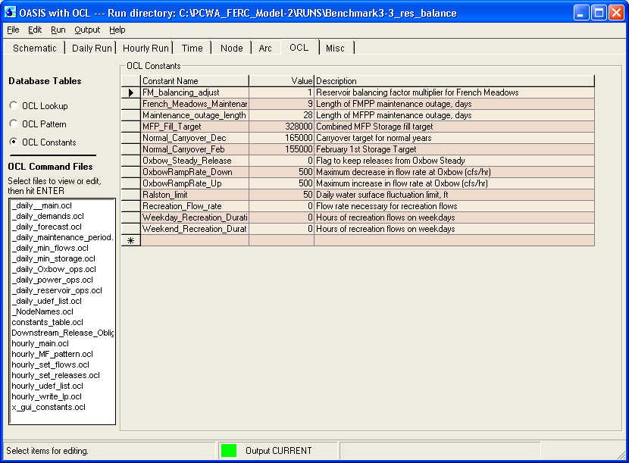

Restarting the system after the maintenance period is done through a maintenance restart flag in the Model. Refilling of Ralston Afterbay begins with 100 cfs through Ralston powerhouse until Afterbay’s elevation reaches 1155 feet. Flow through Ralston is then increased to 200 cfs until the elevation reaches 1168 feet. This type of stepped operation is used to reduce stirring up sediment from the bottom of the reservoir. Therefore the maintenance period restart flag has three states; the flag is set to 1 when the maintenance period ends and is set to 2 when the elevation of Ralston Afterbay increases above 1155 feet. The flag is then set to zero when the elevation reaches 1168. Targets are set on both Ralston Powerhouse and Middle Fork Powerhouse to bound the flows during this time to being below these levels of 100 and 200 cfs. During the maintenance period restart there are additional targets on releases from the upstream reservoirs to ensure that the reservoirs do not release large amounts of water directly following the maintenance period, immediately filling Ralston Afterbay.

Term 91
Term 91 is a condition added to all new water rights in areas tributary to the Delta for the purpose of making them partially responsible for meeting delta outflow or delta water quality standards. PCWA could potentially fall into this group. The State Water Resources Control Board’s attempt to impose Term 91 on the El Dorado Irrigation District was overturned by the Court because the date of their water right, assigned by the State, preceded the imposition of Term 91 on other water right holders. PCWA’s water right also has a date assigned by the State which precedes the imposition of Term 91. If the State Board ultimately decides to impose Term 91 on El Dorado, then it will have to do it in a way that imposes it on all water right holders using the State filing assigned dates, including PCWA. When DWR invokes Term 91, direct diversions for consumptive use are not allowed. Diversions for hydropower are still permitted; therefore the most important effect of Term 91 is that the Auburn and Folsom diversions to meet consumptive demand can only take water released from storage.

Water Forum Agreement
Placer County Water Agency, as a member of the Water Forum, has agreed to make additional releases to downstream water users in dry years. The additional releases are in effect mitigation water for consumptive deliveries in excess of Water Forum baseline amounts. The total obligation can exceed 120,000 AF. Consumptive deliveries can total 120,000 AF and mitigation water can reach 47,000 AF. In years where the mitigation is at the maximum, consumptive deliveries are at minimum.

PCWA Water Forum Obligations
In the period from March through December mitigation water must be released when Folsom Unimpaired Inflow (FUI_m-n) is less than 950,000 AF. The amount of mitigation water required starts at 0 when the inflow threshold of 950,000 AF is reached and increases linearly to a maximum of 47,000 AF as the inflow decreases to 400,000 AF.

- PCWA will always deliver 35,500 AF at the American River Pump Station Mitigation releases are linearly interpolated from 0 AF when FUI_m-n is 950,000 AF to 27,000 AF when FUI_m-n is 400,000 AF. The mitigation releases are in addition to scheduled deliveries.
- PCWA will deliver 30,000 AF to Roseville in years when the FUI_m-n is greater than or equal to 950,000 AF. The amount of delivery to Roseville decreases linearly from 30,000 AF to a minimum of 20,000 AF as the inflow decreases from 950,000 AF to 400,000 AF. Mitigation releases are linearly interpolated from 0 AF when FUI_m-n is 950,000 AF to 20,000 AF when FUI_m-n is 400,000 AF. The mitigation releases are in addition to scheduled deliveries.
- PCWA will deliver 25,000 AF to San Juan in years when the FUI_m-n is greater than or equal to 950,000 AF. The amount of delivery to San Juan decreases linearly from 25,000 AF to a minimum of 10,000 AF as the inflow decreases from 950,000 AF to 400,000 AF. No mitigation releases are required for San Juan.
- PCWA will deliver 29,000 AF to San Juan Suburban when the FUI_m-n is greater than 1,600,000 AF. When FUI_m-n is below 1,600,000 SSWD receives no water.

Refill Agreement
Normal operations of the Middle Fork Project result in a December 31 carryover target of 150,000 acre feet. When PCWA makes a water sale, the December 31 carryover target becomes 150,000 minus the volume of the sale. At the beginning of the following year, PCWA will operate the MFP to refill the reservoirs assuming that the year is wet enough to do so. If the Bulletin 120 Apr-Jul forecast is for a Folsom Unimpaired Inflow of more than 1,120 TAF, then the MFP reservoirs are allowed to refill and the debt is considered repaid. However, if the Bulletin 120 Apr-Jul forecast is less than 1,120 TAF, PCWA will need to operate the reservoir so that the December 1 carryover target is the same as the previous year. (150,000 – the volume of the sale). This debt will continue until the Bulletin 120 Apr-Jul forecast exceeds 1,120 TAF. The refill agreement is tied not only to the Water Forum Agreement, but also any other water sales that the Agency may make. If the Agency doesn’t get paid for the additional releases that cause the MFP reservoirs to fall below 150,000 TAF on December 1, (i.e., the water is not sold), the refill agreement does not apply and the reservoirs can continued to be operated normally.

Model Output

Model Output
As the Model is running each simulation, the solution for each day is stored in a file of results. This file is located in the run folder under the filename output.dss and includes:

- Flows (AF) for each stream reach and all project tunnels (arcs).
- Storage and water surface elevation at French Meadows, Hell Hole Reservoirs, and Ralston Afterbay (nodes).
- Generation at French Meadows, Hell Hole, Middle Fork, Ralston, and Oxbow powerhouses (nodes).
- Water deliveries (AF) for downstream consumptive use diversion at PCWA’s American River Pump Station and from Folsom Reservoir to the City of Roseville, San Juan Water District, Sacramento Suburban Water District, and for exchanges with the Central Valley Project.
- User Defined Variables such as forecasts, generation volumes, flags, etc.

Summary of Simulation Results
The model user can selectively extract and format data from the output results file and construct graphs or tables to illustrate specific comparisons. The model user may also use one of a number of pre-set graphic or tabular summaries to more expeditiously display and analyze results.

Tabular Results
Tabular output can be created for review of several data types including storage, elevation, flow, and generation data and are the basis for the graphical representations discussed in the next section. Every graphical representation must have a tabular counterpart. Tabular information can be requested for specific time periods (a particular year or sequence of years). Tabular data can be comma delimited for easy export into a spreadsheet for independent analysis. The following is an example of tabular output.

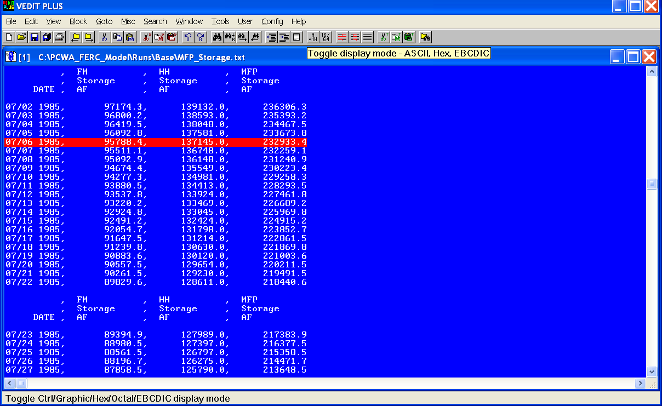

The output table above shows four columns of daily data. The first column is the date, followed by three columns of simulated French Meadows, Hell Hole and Total Middle Fork Project storage data. The post-processing tools have the ability to perform mathematical operations. In this example the French Meadows and Hell Hole storage is added to calculate the total project storage listed in the last column. Each of the columns is comma delimited for easy import to a spreadsheet. In addition, the column titles are repeated so that the user can identify each column as they browse through the file. These repeating column titles can be removed for spreadsheet import. For detailed descriptions of all the tabular output options, see the OASIS user’s manual.

Standard Output
Placer County Water Agency has prepared a list of standard output, which will be available with every simulation. Standard output is listed in Appendix F – Model Standard Output List. The standard output has been prepared to allow users to quickly extract tabular or graphical data of interest for analysis using the post-processing tools contained within the model. Alternately, the tabular data can also be created for spreadsheet analysis.

Graphical Results
Graphs can be displayed as line graphs or histograms (bar graphs) as shown in the following examples. They can also be shown for specific time periods (a particular year or sequence of years). The sample graphs in the following figures show a “scroll bar” on the bottom of the graph. The slider can be moved to the left or right to change the time period displayed. The slider can also be removed for screenshots.

Data for the results file may also be displayed as an exceedance curve. In this case, the data displayed as the percent of the time interval analyzed that a certain value is exceeded. Examples of exceedance curves are also shown in the following figures.

Pre-set Graphic Summaries will be available to allow the user to:

- Compare the amount of reservoir storage at French Meadows and Hell Hole reservoirs;
- Compare reservoir elevations at French Meadows and Hell Hole reservoirs and Ralston Afterbay;
- Compare combined reservoir storage at French Meadows and Hell Hole reservoirs on December 1st (carry over target);
- Compare flows through dam spillways by volume, frequency, and duration;
- Compare flows through the Middle Fork Powerhouse as a surrogate measure of total water stored and released by the MFP (in absolute value or percent exceedance);
- Compare flows (in absolute value or percent exceedance) in specified diversion reaches;
- Compare change in flow volume and water elevation (in absolute value or percent exceedance) in the reach of the Middle Fork American River below the discharge of the Oxbow Powerhouse; and
- Compare generation produced at each powerhouse and by the MFP in total by generation rate period (peak, intermediate peak, off-peak) for a selected time period (time of day, day of the week, month, year or number of years).

Samples of the displays of the graphic tools are shown in the following figures. Each is an illustration showing what the display will look like. They are for illustration only and do not show actual results.

Reservoir Storage
The following illustrate the graphs that are available to analyze user alternative changes to reservoir storage.

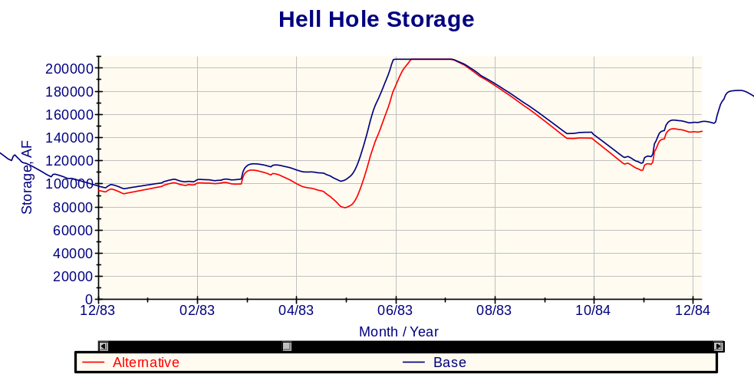

The illustration shows a base case and alternative storage curve for a single year. In the illustration, the user alternative has placed a higher demand water supply from Hell Hole than the base study. The scroll bar at the bottom of the chart can be used to view any year within the period of record. This type of display can be used to look at several alternatives at once and both the X Axis and Y Axis are scalable.

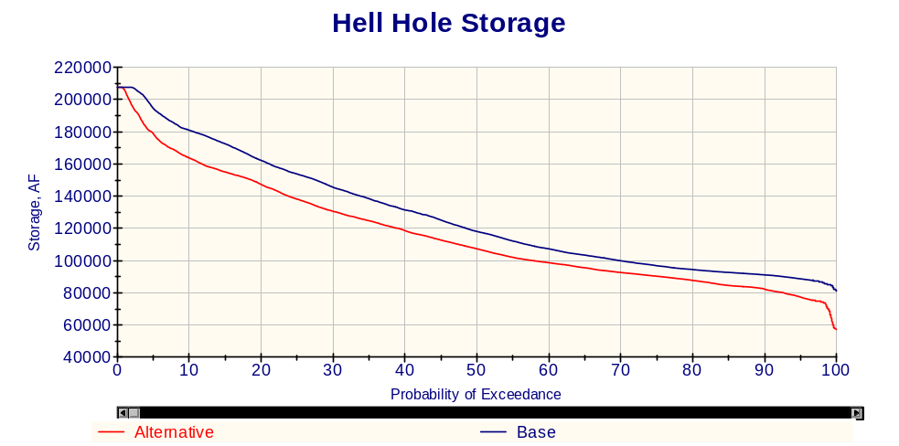

This illustration shows the same comparison as the one above but for the entire period of record as an exceedance plot.

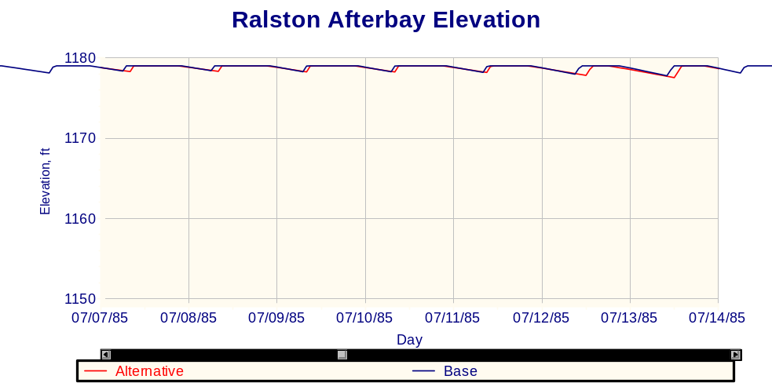

This illustration is an example of Ralston Afterbay operations in terms of elevation for the period of one week. The graph compares the alternative to the base.

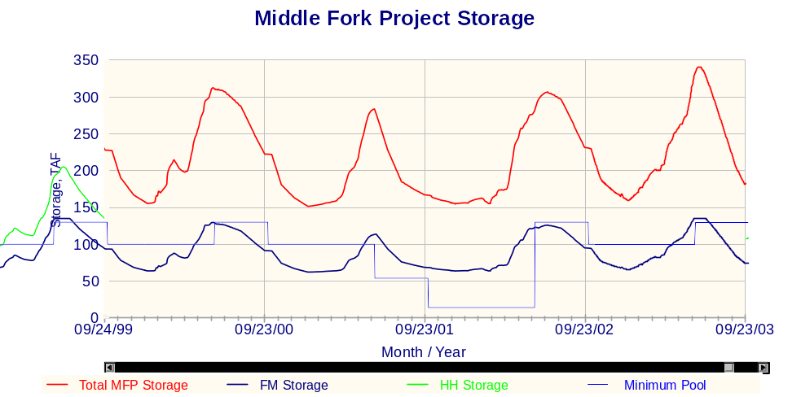

This illustration shows a graph of total Middle Fork Project storage over four sequential years of operation. It includes individual traces for French Meadows storage, Hell Hole storage, total Middle Fork Project storage and the minimum pool (combined minimum storage requirements in the current FERC license).

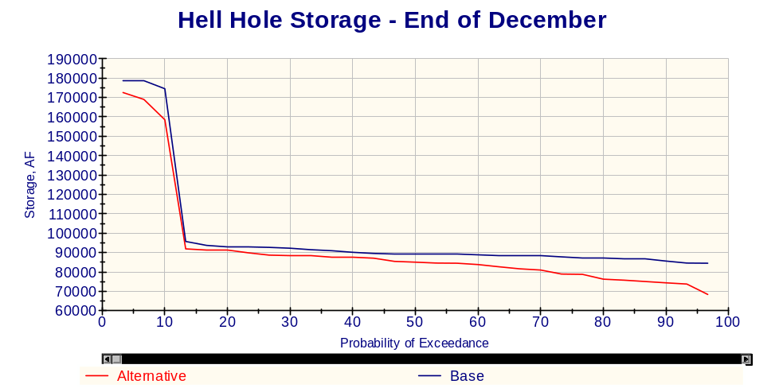

This example shows the storage at Hell Hole Reservoir on December 1st, the reference date for the carry over target as an exceedance graph. Such a graph would need to be combined with a similar graph for French Meadows Reservoir to determine if the carry over target has been achieved. This graph shows the contribution of Hell Hole Reservoir to the carry over target.

Flows in Diversion and Downstream Reaches
The following illustrate the graphs that are available to analyze user alternative changes to flows in diversion and downstream reaches.

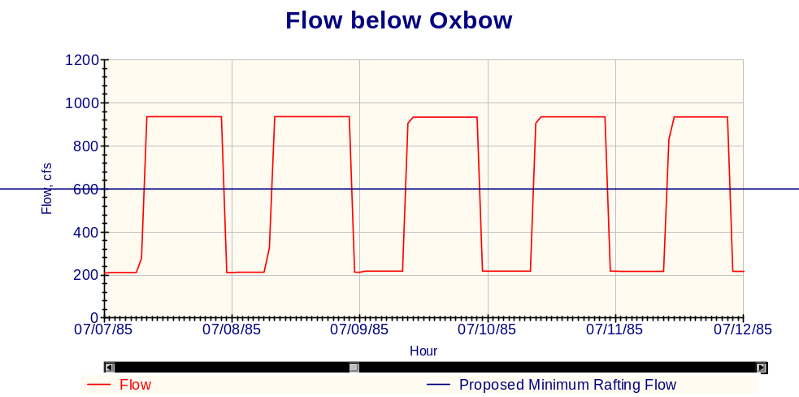

This illustration shows flow for a 5-day time period. Its shape is a function of the peaking operation of the Middle Fork, Ralston, and Oxbow powerhouses where the units are on for a block of time (approximately 14 hours) that includes the peak energy demand period, then turned off (approximately 10 hours). In addition, a line has been added to the graph showing a user alternative recreation flow criteria. This graph then compares operating flows below Oxbow Powerhouse with a desired recreation flow.

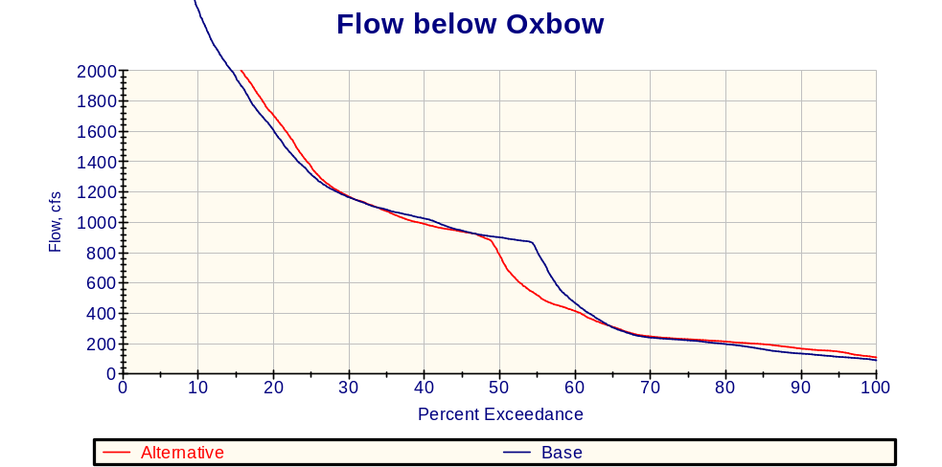

The chart above may also be useful to recreational interests. It shows that the base study provides flows above 600 cfs about 57% of the time while the alternative provides flows above 600 cfs about 53% of the time.

Generation
The following illustrate the graphs that are available to analyze user alternative changes to project generation.

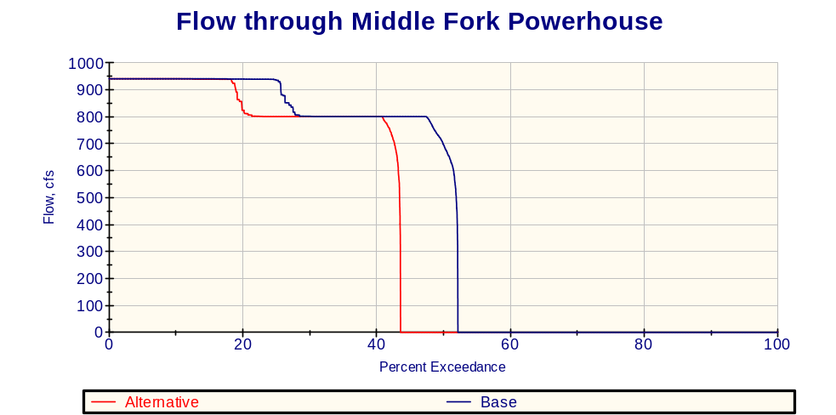

This illustration is an exceedance curve of flows through the Middle Fork Powerhouse. It shows that the MFP generates power about 52% of the time and that generation occurs at or near full load when the powerhouse is in operation. The illustration shows that the user alternative further reduces the frequency of generation by approximately 8%.

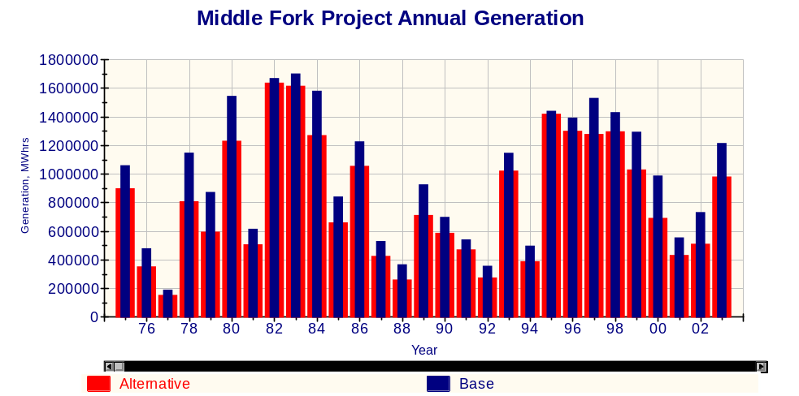

This illustration is a chart showing total annual generation (in megawatt hours) produced by the Middle Fork Project under the base case and for a user alternative.

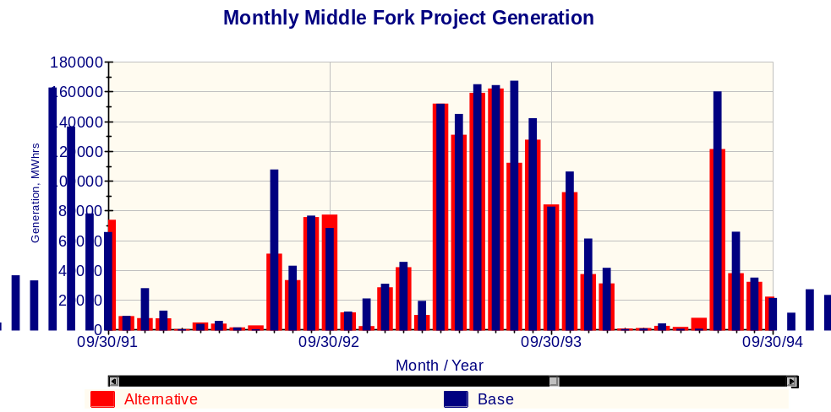

This illustration is similar to the one above but is total monthly generation for a three year period and shows the annual pattern of concentrating generation during certain periods of the year. In the illustration, each bar represents generation for a month. The differences in the bars indicate how the alternative effects the project generation.

Diagnostics

Balance.out
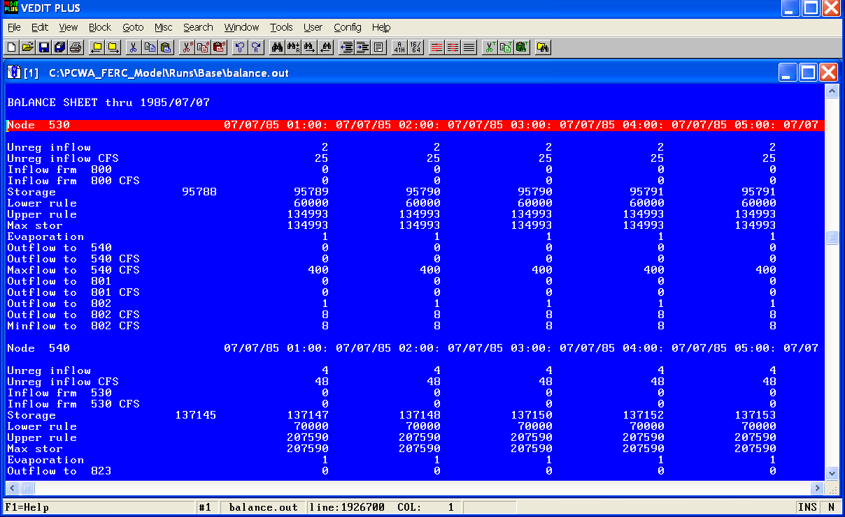
For every simulation OASIS creates a large tabular text file called balance.out that contains a balance of water entering and leaving each node in the system for each time step in the simulation. The example above shows the balance of water at French Meadows reservoir, node 530. This example shows the water balance for hours 1 through 5 for July 7, 1985. The storage value on the far left is the storage at the end of the previous time step, in this case for 07/06/1985 24:00. This illustration shows the unimpaired inflow, the diversion from Duncan Creek (node 800), the diversion to Hell Hole (node 540), the release through the spillway (node 801), the release to the river (node 802), and the minimum instream flow requirement below the reservoir. In addition the balance sheet shows the evaporation and the storage at the reservoir and pertinent restrictions such as lower rule, upper rule and maximum storage. The balance sheet displays flows in both acre-feet and cubic feet per second (cfs).

OCL.out
For every simulation OASIS creates a large tabular text file named OCL.out that contains a summary of all user defined variables (udefs), constraints, and targets in the model, shown below. This shows all targets, which condition of the target was evaluated, the penalties for being above or below the targeted values, and the priority of the target.

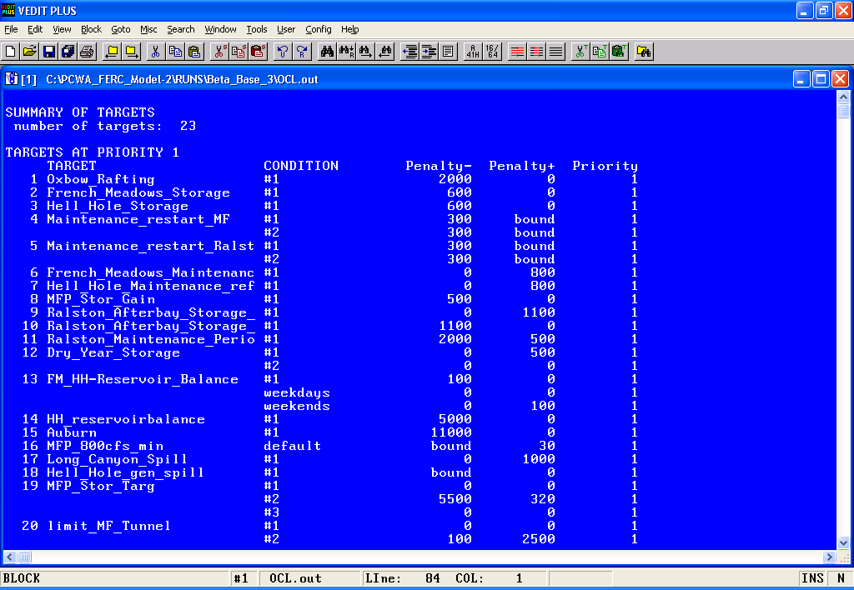

Below that section, for each time step, the value that the model set for each udef and which condition the model used to select that value. It also contains the values set for each target in the model and which condition the model used to select that value.

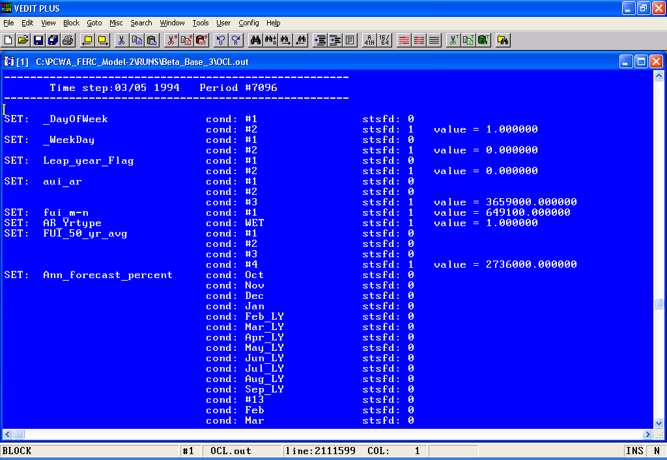

After displaying the value selected for each target, the file contains the slack or surplus on each target, as well as the weights on each target. Where the value of a target is above or below the targeted value, it multiplies the slack or surplus by the weight to get the total penalty incurred.
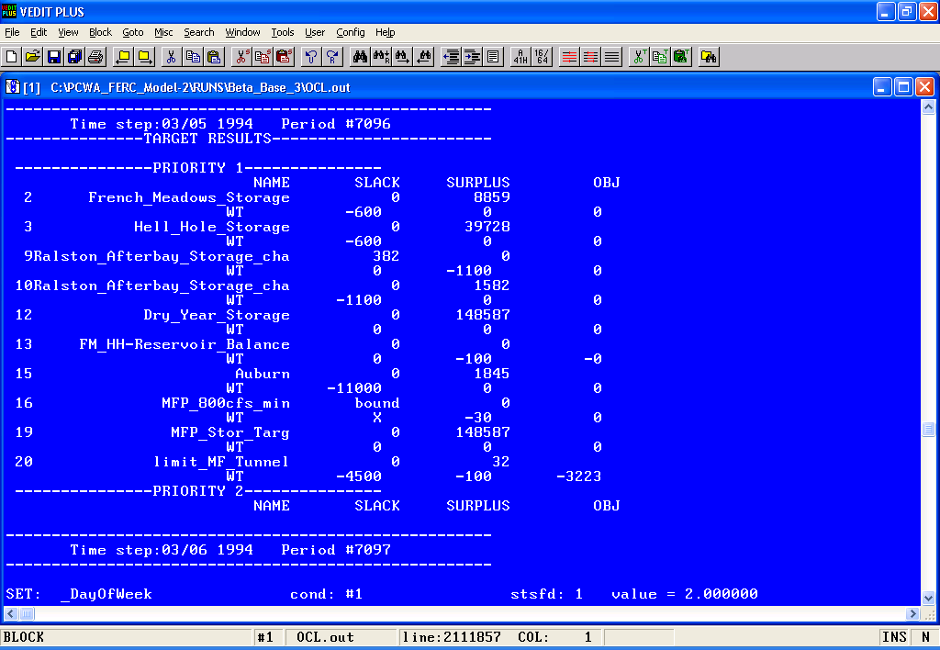

LP.out
LP.out is a file that contains all the linear equations that the model uses to route water. In the base case, and in basic model operation, the output to LP.out is shut off. Turning on LP output slows down model runs considerably and its detailed output is usually not necessary for basic diagnostics but sometimes can be helpful in understanding unexpected model results. LP output can be switched on in the Misc tab as shown below. Shown is the model as set in the base case, and circled is the radio button which should be turned on to see LP output. After changing the radio button the simulation run will need to be run again.
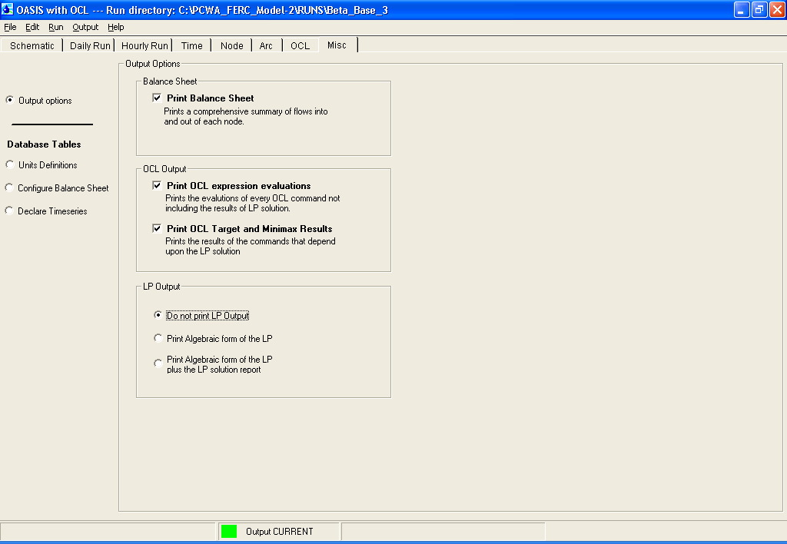

After re-running the simulation, the LP output is opened under the Output drop-down menu. Shown below is an example of a selection of one time step.

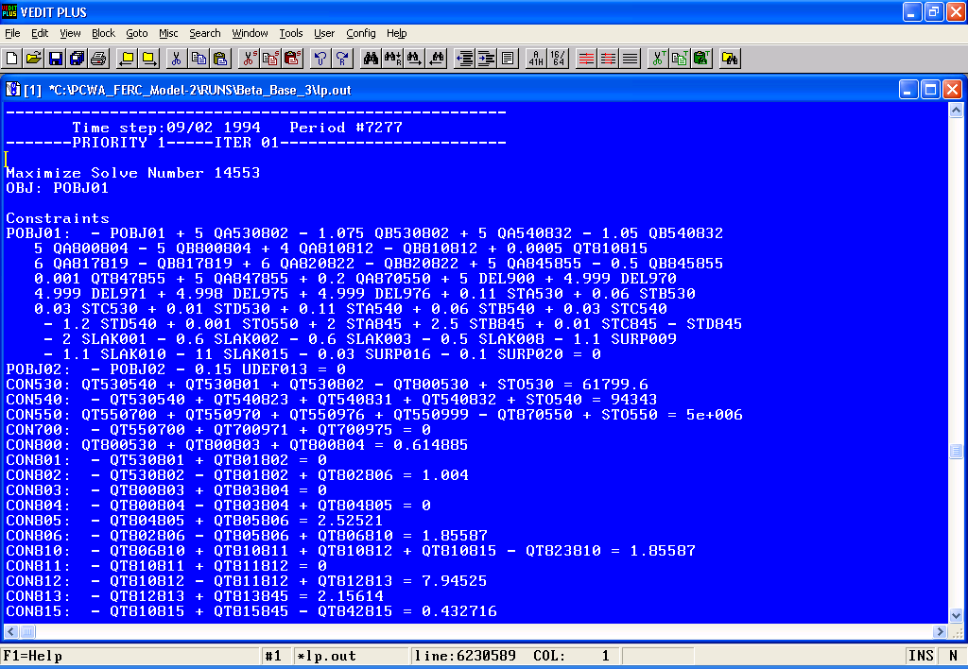

Appendix A
Demand Table
Name | Factor | Month | Value
PCWA Demand | 1 | 1 | 0.035
 |  | 2 | 0.04
 |  | 3 | 0.05
 |  | 4 | 0.06
 |  | 5 | 0.095
 |  | 6 | 0.125
 |  | 7 | 0.145
 |  | 8 | 0.135
 |  | 9 | 0.125
 |  | 10 | 0.08
 |  | 11 | 0.06
 |  | 12 | 0.05
Roseville Demand | 1 | 1 | 0.035
 |  | 2 | 0.04
 |  | 3 | 0.05
 |  | 4 | 0.06
 |  | 5 | 0.095
 |  | 6 | 0.125
 |  | 7 | 0.145
 |  | 8 | 0.135
 |  | 9 | 0.125
 |  | 10 | 0.08
 |  | 11 | 0.06
 |  | 12 | 0.05
San Juan Demand | 1 | 1 | 0.035
 |  | 2 | 0.04
 |  | 3 | 0.05
 |  | 4 | 0.06
 |  | 5 | 0.095
 |  | 6 | 0.125
 |  | 7 | 0.145
 |  | 8 | 0.135
 |  | 9 | 0.125
 |  | 10 | 0.08
 |  | 11 | 0.06
 |  | 12 | 0.05
SSWD Demand | 1 | 1 | 0.035
 |  | 2 | 0.04
 |  | 3 | 0.05
 |  | 4 | 0.06
 |  | 5 | 0.095
 |  | 6 | 0.125
 |  | 7 | 0.145
 |  | 8 | 0.135
 |  | 9 | 0.125
 |  | 10 | 0.08
 |  | 11 | 0.06
 |  | 12 | 0.05

Appendix B
Tunnel and Powerhouse Capacities
Arc | U/S Number | D/S Number | Max Flow | Units
Hell Hole Powerhouse | 540 | 823 | 920 | cfs
Peterson WTP | 550 | 700 | 232 | cfs
Duncan Diversion Tunnel | 800 | 530 | 400 | cfs
NF Long Canyon diversion tunnel | 817 | 823 | 100 | cfs
SF Long Canyon diversion tunnel | 820 | 823 | 200 | cfs
Oxbow Powerhouse | 845 | 847 | 1088 | cfs
French Meadows Hell Hole Tunnel | 530 | 540 |  | cfs
Lower Hell Hole - Middle Fork Tunnel | 540 | 823 |  | cfs
Middle Fork to Ralston Tunnel | 810 | 815 |  | cfs
Middle Fork Powerhouse | 823 | 810 | 800 | cfs

Appendix C
Operations Control Language Input Guide
Operations Control Language Input Guide

Filename | Description | Modification Allowed
_daily_main.ocl | Contains some basic information pointing the model to input files. | No
_daily_demands.ocl | Contains consumptive water demand quantity and patterns. | To quantity but not pattern
_daily_forecast.ocl | Contains information about leap years, unimpaired flow forecasts, snowmelt runoff forecasts, precipitation forecasts and year types. | Yes
_daily_maintenance_period.ocl | Contains information about when the maintenance outage periods occur for the power houses. | Yes
_daily_min_flows.ocl | Contains minimum instream flow requirements for current license | Yes, when testing new license conditions
_daily_min_storage.ocl | Contains minimum pool requirements for French Meadows and Hell Hole | Yes, when testing new license conditions
_daily_Oxbow_ops.ocl | Contains information about operations during the maintenance outage period. | Yes
_daily_power_ops.ocl | Contains logic for determining when and how much generation should occur on a daily basis. | Yes
_daily_reservoir_ops.ocl | Contains logic for French Meadows, Hell Hole, and Ralston Operations. (i.e., spill logic and reservoir balancing) | Yes
_daily_udef_list.ocl | Contains list of user defined variable names. | Yes, when creating new logic
Downstream_Release_Obligations.ocl | Contains logic for calculating Term 91 and Water Forum Agreement release obligations | No
_NodeNames.ocl | Contains list of node names and corresponding node numbers. This list is automatically generated by the OASIS GUI | No
Constants_table.ocl | Contains list of constant names and corresponding values. This list is automatically generated by the OASIS GUI | No
x_gui_constants.ocl | Contains information about selections made on Setup page. This information is automatically generated by OASIS GUI | No

Appendix D
Load Curve Derivation
Derivation of Load Curve
MFP Operations Model

Introduction & Overview

The MFP is “water limited”; that is, there is less water available for release through the turbines in most year classes than there is turbine capacity. As a result, the MFP operates in “peaking” mode for some or much of the year. Since the project must operate every day (to provide water for minimum releases and consumptive use downstream of the project), the most economic style of operation is to release water: a) during the times of the day when the electrical generation of the project is most valuable; and b) at an efficient operating level for the turbines. As a result, in peaking mode the larger powerhouses (Middle Fork and Ralston) are operated for less than 24 hours per day, but often at nearly full hydraulic and electrical output during those hours. French Meadows Powerhouse is typically also operated in peaking mode. Oxbow powerhouse is operated in peaking mode to the extent possible, but must also operate as necessary to provide downstream flows (including minimum instream flows or water for consumptive purposes).

Additionally, the MFP is to the extent possible operated during the most valuable seasonal time periods; that is, during periods when either the electrical system load is high (often leading to high prices), or during periods when other factors (such as a high price of natural gas) dictate high value for electricity. High prices and/or high demand periods may vary substantially from month-to-month and year-to-year.

The MFP is currently operated under a long-term contract with PG&E, and is dispatched to meet PG&E’s needs. As a proxy for the dispatch pattern that PG&E follows, a load curve for Northern California was developed for use in the MFP Operations Model.

2005 NP 15 Load Curve

NP 15 is the grid zone that generally encompasses Northern California, and therefore represents the demand pattern to which the MFP is most likely to be operated in response.

NP 15 load data was gathered from the California Independent System Operator (CAISO) and was synthesized into a daily average load for the NP 15 zone. The NP-15 load pattern is shown in the Figure 1.

The seasonal load shows generally higher demands for energy during the warmer summer months of June through September, with additional lesser spikes in demand corresponding to cool weather in December and January. Additionally, the load curve shows a weekly pattern of higher demands during the work week and lower demands during the weekends. Finally, occasional ‘spikes’ of high demand for individual weeks likely reflect aberrant weather – extremes of hot or cold for the week.

The 2005 load pattern represents a reasonable proxy of how the MFP might be dispatched (operated), following load cues for the Northern California region. This load curve could be considered the “base” pattern for load response for the MFP.

Figure 1. 2005 Daily Average NP-15 Load

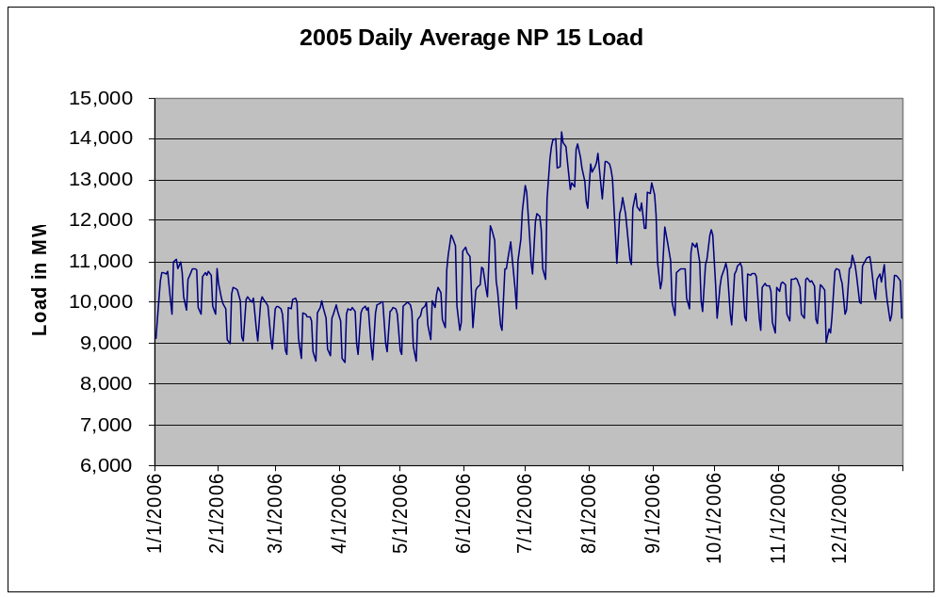

Appendix E
Target Descriptions
Priority 1 Targets
- Auburn – This targets flow in the Middle Fork American River at Auburn to be no less than the sum of demands.
- Dry Year Storage – This targets storage at French Meadows plus storage at Hell Hole on September 30th to be no more than storage from the previous October 1st in years where the Folsom unimpaired April through September forecast is less than 600,000 AF.
- FM-HH Reservoir balance – This targets flow in French Meadows powerhouse during April and May in wet or above normal years when French Meadows storage is above 65,000 AF. When these conditions are met, the flow is targeted to be 400 cfs, in order to push water out of the reservoir. This target is also used to target the flow to be zero on weekends.
- French Meadows Maintenance refill – Targets the releases from French Meadows to be equal to minimum instream flow requirements during the maintenance refill. This is done to ensure that the reservoir does not release large amounts of water directly following the maintenance period in an attempt to refill Afterbay.
- French Meadows Storage – Targets French Meadows Storage to be no less than French Meadows lower rule.
- HH reservoir balance – This targets flow through the Middle Fork tunnel out of Hell Hole reservoir. If Hell Hole storage has been above 90% of full capacity at any time in the last 5 days, the flow is targeted to be maximum flow through the tunnel.
- Hell Hole Maintenance refill – Targets the releases from Hell Hole to be equal to minimum instream flow requirements during the maintenance refill. This is done to ensure that the reservoir does not release large amounts of water directly following the maintenance period in an attempt to refill Afterbay.
- Hell Hole Storage – Targets Hell Hole Storage to be no less than Hell Hole lower rule.
- Hell Hole spills – This targets flow through the Hell Hole minimum instream flow requirement arc to be no greater than the minimum instream flow requirement, forcing spills to go through the spills arc.
- Limit MF Tunnel – This targets Flow through Middle Fork powerhouse to be equal to the variable Daily_generation. The target contains many conditions, each with differing weights.
- Long Canyon Spill – This targets Long Canyon diversions to be zero when spill control operations are in effect.
- Maintenance restart MF – Targets the flow through Middle Fork powerhouse to be equal to 100 cfs when Ralston Afterbay elevation is less than 1155 feet, and equal to 200 cfs when Ralston Afterbay elevation is greater than 1155 feet and less than 1168 feet.
- Maintenance restart Ralston - Targets the flow through Ralston powerhouse to be equal to 100 cfs when Ralston Afterbay elevation is less than 1155 feet, and equal to 200 cfs when Ralston Afterbay elevation is greater than 1155 feet and less than 1168 feet.
- MFP 800cfs min – This targets flow in Middle Fork powerhouse to be equal to an integer multiple of an hourly flow of 800 cfs.
- MFP Stor Gain – This prevents the MFP project from gaining storage during the months of July through October, although it does allow ponding of up to 30 days. In general, this is the dispatch cycle of the MFP project and the project is not gaining storage.
- MFP stor targ – This targets combined MFP storage to be equal to the variable Daily_MFP_Target during the months of October and November.
- Oxbow Bypass – This prevents Oxbow from generating during the maintenance period. During the Middle Fork maintenance period consumptive demands are passed through the minimum instream flow requirement arc.
- Oxbow Gen 1 – This targets flow through the Oxbow powerhouse to be equal to available storage at Ralston plus inflow to Ralston.
- Oxbow Gen 2 – This targets flow through the Oxbow powerhouse during the maintenance period and maintenance period restart.
- Oxbow Rafting – Targets flow in Middle Fork American at Foresthill to be no less than minimum instream flow requirement plus the required recreation volume. Recreation volume is calculated from the recreation flows parameters entered in the constants table.
- Ralston maintenance period – This targets the storage in Ralston Afterbay to be equal to 818 AF during the maintenance period.
- Ralston Afterbay Storage change-I – This targets the storage in Ralston Afterbay to be no more than the variable Ralston_UpperLimit
- Ralston Afterbay Storage change-II – This targets the storage in Ralston Afterbay to be no less than the variable Ralston_LowerLimit

Priority 2 Targets
- FM reservoir balance – This targets flow in the French Meadows powerhouse for reservoir balancing.
- FM Spill Flow – This keeps French Meadows powerhouse running at full capacity for 15 days following spills at French Meadows.
Summary of UDEFS
- _DayOfWeek – The day of the week, expressed as an integer. 1= Saturday, 7= Friday.
- _WeekDay – A flag that is true when it is a weekday.
- Ann_forecast_percent – Bulletin 120 forecasted April through September unimpaired inflow to Folsom as a percentage of the 50 year average.
- AR_Yrtype - Year type based on the American River unimpaired runoff forecast. Three year types, wet, average, and dry.
- aui_AR – American River unimpaired runoff from October through March plus the forecasted April through September runoff.
- B120_Forecast – Bulletin 120 forecast as a percent of average.
- carryover_target – Combined MFP storage December 1st carryover target.
- daily_generation – The generation volume for the day. In wet conditions, this is the maximum flow through the Middle Fork powerhouse. During normal conditions, this is equal to the period’s generation volume multiplied by the Power Demand Ratio. During December and January, this is equal to the 10-day average MFP inflow.
- Daily_MFP_target – A volume that will be set as the daily target for total MFP storage during October and November.
- EOM_Storage – The combined MFP storage at the end of the previous month.
- Feb_Conservative – When the first bulletin 120 forecast comes out in February, confidence in this forecast is fairly low. As further forecasts come out, the confidence increases. Because of this, the effect of non-average forecasts during the month of February is reduced by a factor equal to Feb_conservative.
- FM_Flow_req – French Meadows minimum instream flow requirements for the generation period. During the fill period this is minimum instream flow requirement, summed through the end of June. During the dispatch period this is the minimum instream flow requirement, summed through the end of February.
- FMPP_Maintenance_period – French Meadows powerhouse maintenance period counter. Set to 1 on the first day of the maintenance period, increases by 1 with each day until the end of the maintenance period, at which point the flag is set to zero.
- FM_Res_Bal_On_1 – Flag that that is set to 1 when French Meadows storage goes above 16% of full less than Hell Hole storage, and is set to 0 when storage is less than 12% of full less than Hell Hole Storage.
- FM_Res_Bal_On_2 – Flag that that is set to 1 when French Meadows storage goes less than 4% of full less than Hell Hole storage, and is set to 0 when storage is more than 8% of full less than Hell Hole Storage.
- FM_Res_Bal_On_3 – Flag that that is set to 1 when French Meadows storage goes more than 12% of full more than Hell Hole storage, and is set to 0 when storage is less than 7% of full more than Hell Hole Storage.
- Forecast_inflow – Forecasted MFP inflow for the generation period. Depending on the B120 forecast, forecasted inflow during the fill period includes inflow through the end of May, the middle of June, or the end of June. During the dispatch period, forecasted inflow includes inflow through the end of November.
- FUI_50_yr_avg – The 50 year average unimpaired inflow to Folsom, as listed in the bulletin 120 forecast, updated every 5 years.
- FUI_m-n – Annual unimpaired inflow American River at Folsom.
- FUI_Prediction – A prediction of annual Folsom inflow. The B120 April through September forecast as a percentage of average multiplied by the 50-year average.
- FUI_YrType – Year type based on B120 Folsom unimpaired inflow forecast.
- generation_volume – this is the volume of water that is available for generation during the current generation period. This is not a monthly generation volume, rather a volume for the rest of the period. This value is updated on the first of every month.
- HH_Flow_req – Hell Hole minimum instream flow requirements for the generation period. During the fill period this is minimum instream flow requirement, summed through the end of June. During the dispatch period this is the minimum instream flow requirement, summed through the end of November. This value is read from a pattern table, which lists these volumes in acre-feet.
- HH_Res_Bal_On – Flag that is set to 1 when Hell Hole storage goes above 90% of full, and is set to 0 when storage is less than 86% of full.
- Leap_Year_Flag – Flag that is set to 1 during a leap year, 0 during a non leap year.
- Mar_Conservative – When the first bulletin 120 forecast comes out in February, confidence in this forecast is fairly low. As further forecasts come out, the confidence increases. Because of this, the effect of non-average forecasts is reduced, during the month of March, by a factor equal to Mar_conservative.
- MF_maintenance_counter – Counter for the Middle Fork powerhouse maintenance period. Set to one on the first day of the maintenance period, increased by one every day of the maintenance period, and set to zero after reaching the number of days of the maintenance outage, set in the constants table.
- MF_maintenance_period_length – Length of the maintenance period, in days, set in the constants table.
- MFP_stor_gain
- MFP_stor_today – The combined storage of French Meadows and Hell Hole reservoirs.
- MFP_target_Increment – This is used for daily storage targets during October and November. This is the amount that the daily target will increment each day.
- MFPH_800_Integer – The number of hours that Middle Fork powerhouse will generate for the day. This is used to ensure that daily flow through the powerhouse can be divided up into an integer number of hours at 800 cfs.
- MFPP_Maintenance_period – Flag set to 1 during the maintenance period, set to zero outside of the maintenance period.
- MFPP_Maintenance_period_restart – Flag showing when the maintenance period restart is in effect. Flag is set to 1 while Ralston Afterbay elevation is less than 1155 feet, set to 2 while Ralston Afterbay elevation is less than 1168 feet.
- MM – This is a decision variable used in the minimax command for reservoir balancing. MM is the variable that minimax uses to balance the reservoirs. For more on using minimax, see the OASIS manual section 2.5.1
- Oxbow_Steady_Release – This calculates the steady release volume for Oxbow powerhouse when the Oxbow steady release option is turned on.
- Power_Demand_Acc – An accumulation of power demand index through the end of the generation period.
- Power_Demand_Ratio – The day’s power demand divided by the accumulation of power demand through the end of the generation period.
- Recreation_Vol – daily volume required for rafting requirements.
- Ralston_Avail_Stor – Storage at Ralston Afterbay in excess of the upper rule that is available for generation.
- Ralston_LowerLimit – The lower limit on storage storage at Ralston Afterbay. Note that this is not the minimum storage, but rather the lower limit on normal operations.
- Ralston_UpperLimit – The upper limit on storage at Ralston Afterbay. Note that this is not the maximum storage, but rather the upper limit on normal operations.
- reop_water – This udef is used when the Water Forum Agreement is in effect. This is the annual volume of water that must be released in accordance with the Water Forum.
- SC_Level_high - Higher threshold for spill control operations. Spill control operations begin when combined MFP storage goes above this level.
- SC_Level_low – Lower threshold for spill control operations. Spill control operations cease when combined MFP storage goes below this level.
- SC_Switch – Flag that tells whether the system is in Spill Control operations.
- Term91_Eff – Flag that tell whether Term 91 is in effect.
Summary of Constraints
- French_Meadows_spill_gate – Constrains the storage at French Meadows to be less than 111,602 AF from November through March, when the spill gates are open.
- French_Meadows_Spills – Constrains flow through the French Meadows spillway to be zero when French Meadows is less than full.
- French_Meadows_Spills_gate – Constrains the flow through the French Meadows spillway to be zero when the spill gates are up and the storage is less than 111,602 AF.
- Hell_hole_Spills – Constrains the flow through the Hell Hole spillway to be zero when Hell Hole storage is less than full.
- MF->Ralston_bottleneck – Ensures that Ralston powerhouse diversions are realistic for an hourly balance.
- MFP_800cfs_max – Constrains the flow through Middle Fork Powerhouse in order for the hourly model to assign 0 or 800 cfs for each hour.
- minimax_FM – Constrains French Meadows storage as a percentage of full, multiplied by FM_balancing_factor, to be less than the udef MM. This constraint is in effect from December through May in non-critically dry years.
- minimax_FM_2 – Constrains French Meadows storage as a percentage of full, divided by FM_balancing_factor, to be less than the udef MM. This constraint is in effect August through October in non-critically dry years.
- minimax_HH - Constrains Hell Hole storage as a percentage of full, multiplied by FM_balancing_factor, to be less than the udef MM. This constraint is in effect year-round.
- rediversion_Jul-Sep – Ensures that deliveries to PCWA or its contractors come from rediversion during July through September.
- rediversion_Oct – Ensures that deliveries to PCWA or its contractors come from rediversion during July through October.

Appendix F
Model Standard Output List
MFP Model Standard Output List

French Meadows Reservoir
- Inflow
- Releases / Minimum Flow
- Elevation
- Storage / Minimum Requirements
- Spills

Hell Hole Reservoir
- Inflow
- Releases / Minimum Flow
- Elevation
- Storage / Minimum Requirements
- Spills

Ralston Afterbay
- Storage
- Elevation
- Releases / Minimum Flow
- Spills

Middle Fork Interbay
- Releases / Minimum Flow
- Spills

Rubicon River Streamflow
- above Ralston Afterbay
- above SF Rubicon River
- below SF Rubicon River
- above Long Canyon Creek
- below Long Canyon Creek

MF American River Streamflow
- below American River Pump Station
- above NF American River
- below NF American River
- above Otter Creek
- below Otter Creek
- above Ralston Afterbay
- below Ralston Afterbay
- above Middle Fork Interbay
- below Middle Fork Interbay
- above Duncan Creek
- below Duncan Creek
Duncan Creek
- Inflow
- Releases / Minimum Flow
- Diversions

South Fork Long Canyon Creek
- Inflow
- Releases / Minimum Flow
- Diversions

North Fork Long Canyon Creek
- Inflow
- Releases / Minimum Flow
- Diversions

Otter Creek Streamflow

Generation
- French Meadows Powerhouse
- Hell Hole Powerhouse
- Middle Fork Powerhouse
- Ralston Powerhouse
- Oxbow Powerhouse

Maintenance Outage Length
- Middle Fork Maintenance Period
- French Meadows Maintenance Period

Carryover Target

Fill Target

Rafting Flows

Oxbow Steady Release On/Off

Ramping Rates

Violations
- Minimum Flow Requirements
- Minimum Storage Requirements
- Delivery Shortages

OASIS with OCL is a trademark of Hydrologics, Inc. and is a commonly used model for simulation of hydroelectric system simulation in support of FERC relicensing programs.
The physical capacities used in this model may be different than those reported in the Project description or in the Project engineering drawings because the physical capacities in the model may represent typical or known capacities based on 40 years of operating the MFP.
OASIS is a linear program model that requires the designation of “Goals” that the model seeks to achieve. In its formulation for the MFP, the term operating objectives has been used instead of goals but in the modeling context it has the same meaning.

